Sample question
Tick the correct answer

1.Pages of the manuscript books were made of
(a) Palm leave (b) Peeple Leave
(c) Tulsi Leave (d) Neem Leave
2. Traces of ash in the Kurnool caves indicate
(a) rearing of animals (c) use of stone tools
(b) use of fire (d) use of water.
3. Which of the following is not shown on a relief or physical map?
a) Mountains c) Crops
b) Rivers d) Valleys
4. The name of the region where rice was first grown in India is
a) North of Vindhyas c) on the banks of Tapti river
b) Sulaiman hills d) the Gaxo hills
5.Years after the birth of Jesus Christ are counted
(a) Forward (b) Backward
(c) Upward (d) Downward
(Questions from 6 to 9 consist of 2 marks.)
6.Why did early humans paint on cave walls?
7. How can anyone know what happened in the past?
8. Why does the sun seem to rise in the east and set in the west?
9.How dates are important in history?

10. Case study
The Neolithic Site of Burzahom, in the district of Srinagar, India brings to light transitions in human habitation patterns from Neolithic Period to Megalithic period to the early Historic period. From transition in architecture to development in tool-making techniques to introduction and diffusion of lentil in the north-western India, the site of Burzahom is a unique comprehensive story teller of life between 3000 BCE to 1000 BCE.The remains of the site document the gradual change in the nature of dwelling spaces among early societies. From subterranean dwelling pits, the evidence in the site shows the emergence of mud-structures, thereon mud-bricks constructions on level ground. The range of tools recovered from the site shows the evolution in tool making Neolithic men skilled hunters and their knowledge in applying the implements for cultivation.
- Burzahom site is a storyteller of which time?
- The given case study provides information about which evolution?
- The evidence in this site emerges: which activities?
- To light transitions in human habitation patterns from which period to which period to the early Historic period.
Picture based question.
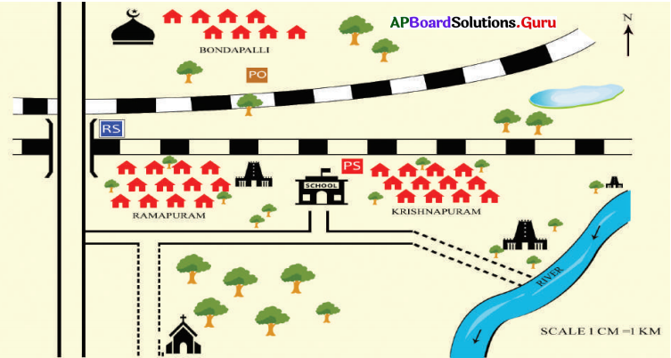

Questions
- Near which village post office is situated?
- The river is flowing in which directions?
- The school is situated in which direction of broad gauge?
- In which direction of school the police station is situated?

